**Exercise 8 Compound Nouns**

You need to construct compound nouns from these words in the box below to fill in the gaps in the sentences. Some of the words are used twice, but in a different order! All answers should be entered as two separate words.

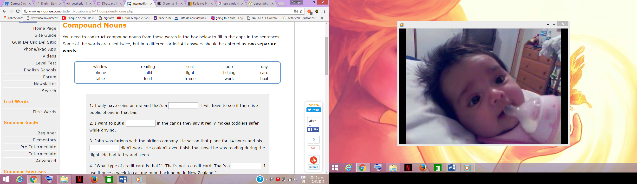

1. I only have coins on me and that's a card phone. I will have to see if there is a public phone in that bar.

2. I want to put a child seat in the car as they say it really makes toddlers safer while driving.

3. John was furious with the airline company. He sat on that plane for 14 hours and his reading light didn't work. He couldn't even finish that novel he was reading during the flight. He had to try and sleep.

4. "What type of credit card is that?" "That's not a credit card. That's a phone card. I use it once a week to call my mum back home in New Zealand."

5. All the ­­­­window frames in this house have to be repainted. Otherwise, they will rot over the winter and then we may not be able to open the windows in the spring.

6. English restaurants have a terrible reputation, but the pub food is very tasty.

7. I worked at night for so long that when I finally started to do some day work, I found it really strange.

8. A fishing boat sank off the Spanish coast last night. Both fishermen were saved by the coast guard.

9. I know that Monday is a holiday for everyone else, but for us it's a normal work day. We have to get this project finished by Wednesday!

10. Why do you have a pub table in the middle of your lounge? I keep feeling tempted to go up to the bar to order drinks!!

**Answers...**

1. . Teléfono de tarjeta
2. child seat.
3. reading light.
4. phone card. Tarjeta de telefono
5. window frames.
6. pub food.
7. day work.
8. fishing boat.
9. work day.
10. pub table.

Work day: dia de trabajo

Day work: trabajo de dia